Project Report with Proof of Completion (POC)
Name: Lakshmi priya A
Register Number: 2403921314922029
Year / Department: 3rd year and CSE (Cyber Security)
Platform: n8n, OpenAI Model, JavaScript, Google Sheets
Project: AI File Upload Vulnerability Tester (RED TEAM - AI VAPT)
1. OBJECTIVE
The objective of this project is to automate the generation of a comprehensive security test matrix for file upload vulnerabilities using Artificial Intelligence and workflow automation in n8n. The system accepts lab environment architecture descriptions through a form trigger, uses an OpenAI LLM to design test vectors for extension bypass, MIME spoofing, and oversized file/DoS risks (explaining each risk and remediation), parses the generated payload structure using JavaScript, and automatically populates the resulting test matrix into Google Sheets.
2. TOOLS AND TECHNOLOGIES
- n8n: Workflow automation platform hosting the end-to-end pipeline.
- Form Trigger Node (On form submission): Captures file upload form descriptions and lab environment constraints from users.
- OpenAI Node (Message a model): Generates structured vulnerability test cases, payload filenames, header MIME spoof vectors, risk explanations, and remediations.
- Code Node (Code in JavaScript): Extracts and cleans JSON responses from the LLM, formatting them into individual structured items.
- Google Sheets Node (Append row in sheet): Saves the generated test-case matrix directly to Google Sheets.
3. WORKFLOW DESIGN
The workflow consists of four main nodes connected sequentially:
[On form submission] ──> [Message a model] ──> [Code in JavaScript] ──> [Append row in sheet]
- On form submission: Triggers the workflow upon receiving target upload form details (lab tech stack, allowed file extensions, server configuration).
- Message a model: Sends system instructions and user form parameters to OpenAI to generate a structured VAPT test matrix covering extension bypass, MIME spoofing, and oversized file attacks with risk explanations.
- Code in JavaScript: Sanitizes the raw LLM output, strips Markdown formatting, parses the JSON array, and maps test scenarios into individual data rows.
- Append row in sheet: Automatically appends each test scenario row to the designated Google Sheet (test_id, category, test_case_name, payload_filename, header_mime_type, risk_explanation, remediation).
4. PROOF OF COMPLETION (POC)
Figure 1: Complete n8n Workflow Architecture
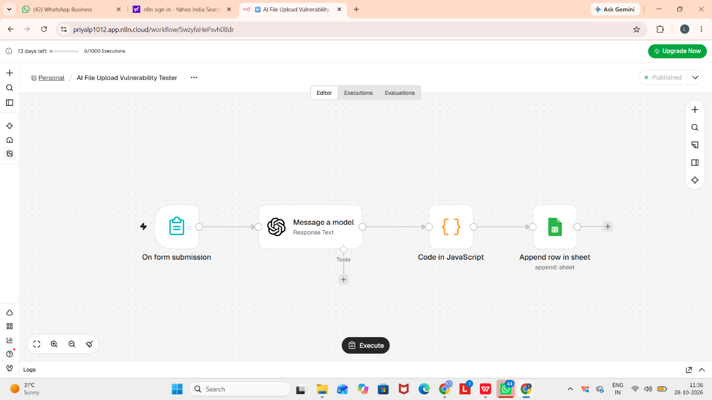

The screenshot shows the complete, active n8n workflow with the On form submission, Message a model, Code in JavaScript, and Append row in sheet nodes connected successfully.

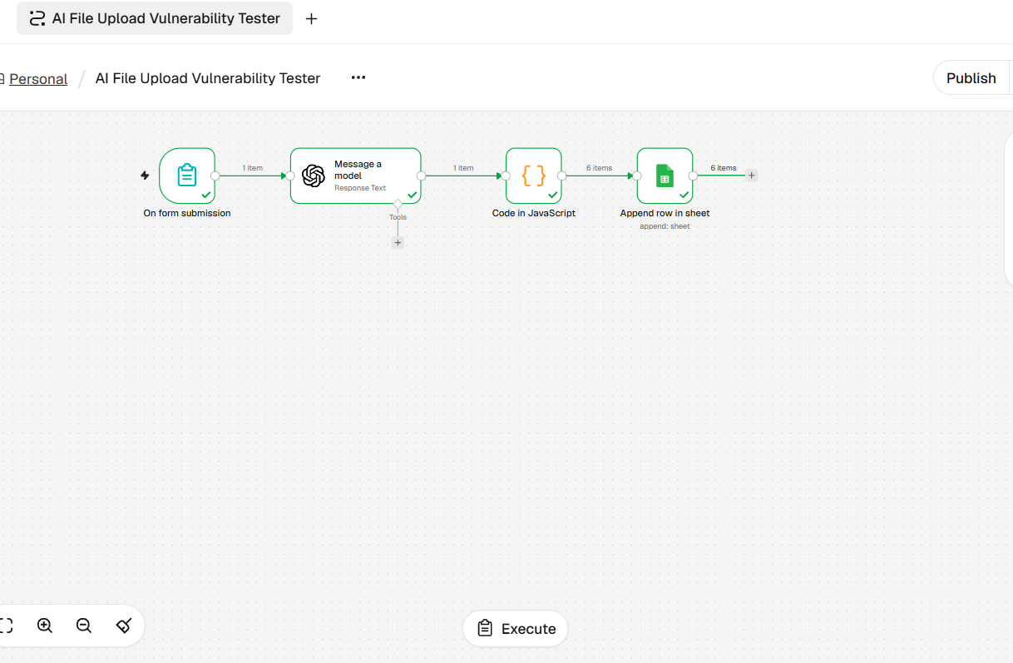

Figure 2: Form Submission Trigger Output
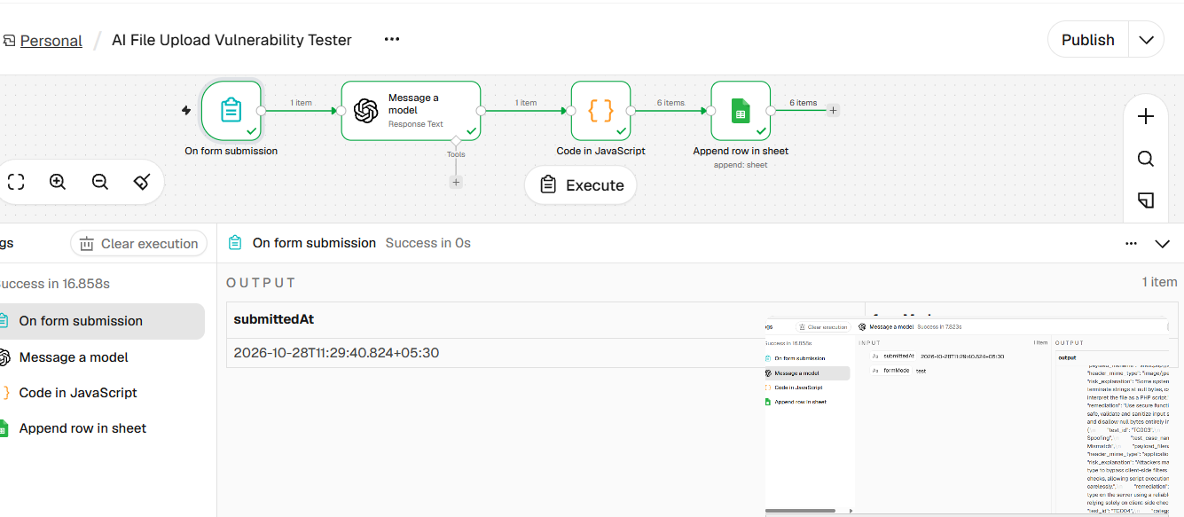
The screenshot shows successful execution of the On form submission trigger node upon capturing input submission parameters.
Figure 3: OpenAI Model Response Generation

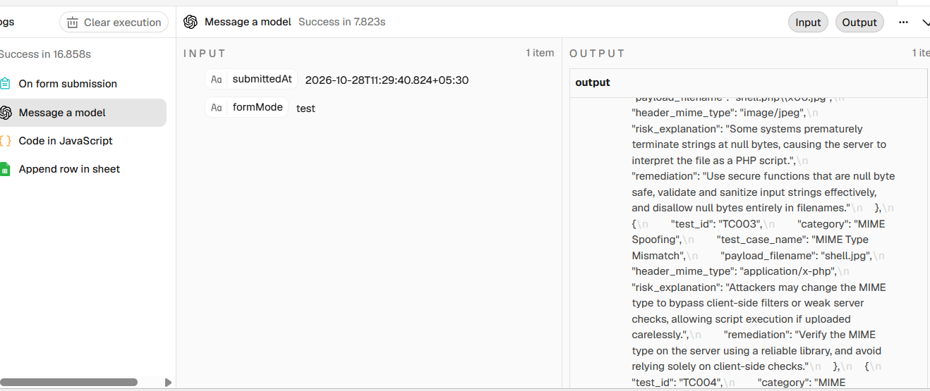
The screenshot displays the Message a model node executing successfully and outputting raw structured JSON containing vulnerability test cases (e.g., TC001, TC002, TC003 for extension bypass, MIME mismatch, and null byte injection).
Figure 4: JavaScript Code Node Data Parsing
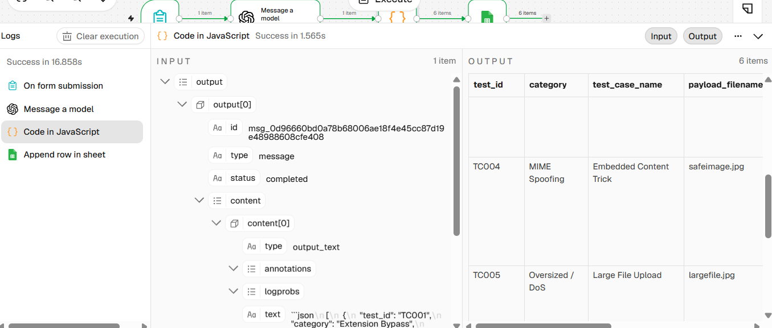
The screenshot shows the Code in JavaScript node receiving raw LLM text input, stripping formatting, and splitting the result into 6 distinct items mapped to columns.
Figure 5: Google Sheets Data Insertion
The screenshot provides proof of completion showing all 6 generated VAPT test cases (TC001 to TC006) successfully appended to Google Sheets with populated fields (test_id, category, test_case_name, payload_filename, header_mime_type, risk_explanation, remediation).
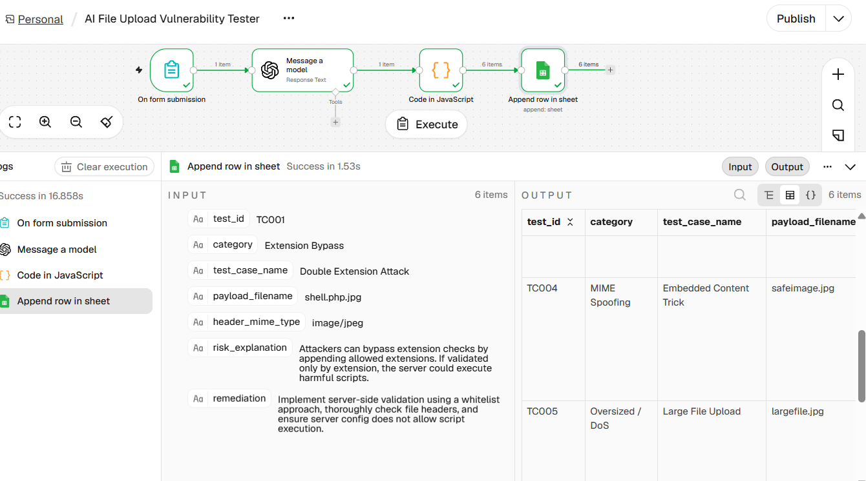
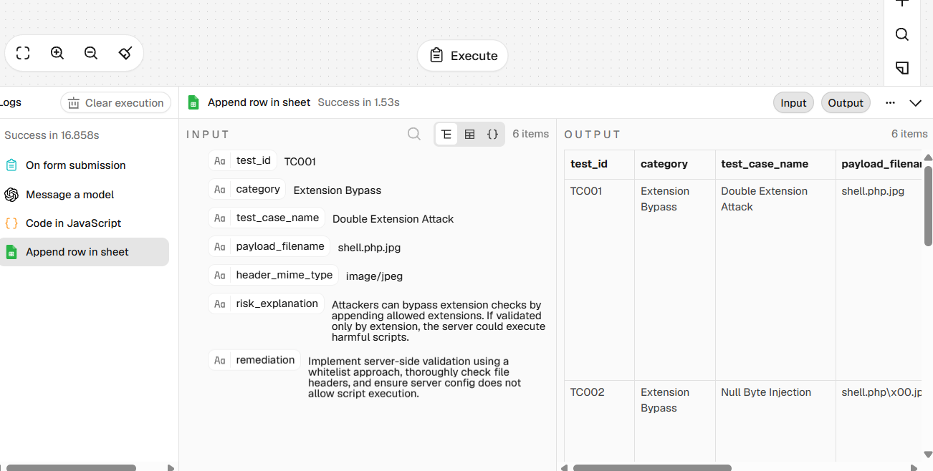

5. TEST RESULTS
- The workflow was triggered using lab upload form input parameters.
- The On form submission node successfully triggered the workflow.
- The Message a model node designed targeted test vectors covering extension bypass (double extensions, null byte injection), MIME spoofing, and oversized file DoS attacks.
- The Code in JavaScript node converted the AI response into 6 structured data items.
- The Append row in sheet node saved all test cases into Google Sheets within 1.53s.
6. CONCLUSION
The AI File Upload Vulnerability Tester project demonstrates how n8n, OpenAI models, and Google Sheets integration can automate Red Team VAPT planning. By transforming high-level form inputs into structured attack matrices with risk explanations and remediation recommendations, this solution speeds up security assessment planning for file upload mechanisms in laboratory environments.
7. SECURITY AND RELIABILITY
- Perform security tests only within authorized laboratory environments.
- Keep OpenAI API keys and Google OAuth credentials secured inside n8n credential managers.
- Verify AI-generated test scenarios manually before executing payloads on target applications.
- Never run automated payload matrices against live production systems without explicit authorization.
8. LIMITATIONS AND FUTURE ENHANCEMENTS
- Limitations:
  - Requires manually triggering/submitting form parameters describing the target upload architecture.
  - Generates static test matrices; actual payload execution is performed separately.
- Future Enhancements:
  - Integrate active HTTP request nodes in n8n to send generated test payloads directly to lab upload endpoints automatically.
  - Send automated alerts to Slack or Telegram when high-risk upload vulnerabilities are discovered.
  - Export reports as formal PDF documentation in addition to Google Sheets.
9. IMPLEMENTATION PROCEDURE
- Create a new workflow in n8n named AI File Upload Vulnerability Tester.
- Add an On form submission trigger node with fields for form description and constraints.
- Add a Message a model (OpenAI) node configured with gpt-4o / gpt-4o-mini.
- Write system prompts directing the AI to generate extension bypass, MIME spoofing, and oversized file test cases in JSON format.
- Add a Code in JavaScript node to parse and structure the JSON array into individual rows.
- Add a Google Sheets (Append row in sheet) node and connect your Google account.
- Match sheet headers (test_id, category, test_case_name, payload_filename, header_mime_type, risk_explanation, remediation) using Auto-Map.
- Execute the workflow, verify data output in Google Sheets, publish the workflow, and capture POC screenshots.
10. APPENDIX
- Workflow Name: AI File Upload Vulnerability Tester
- Input: Form trigger submission containing upload form architecture details
- AI Component: OpenAI Chat Model (gpt-4o / gpt-4o-mini)
- Output: Vulnerability test matrix saved to Google Sheets
- Automation Platform: n8n
- Project Status: Execution completed successfully; screenshots attached as Proof of Completion (POC).

